EXPERIMENT 13: CNN BASED DIGIT CLASSIFICATION
1. PYTHON SOURCE CODE
Cell 1: Model Architecture, Training, and Evaluation
# Cell 1: CNN Model Training & Evaluation (TensorFlow / Keras)
import tensorflow as tf
from tensorflow.keras import layers, models
import numpy as np
# 1. Load dataset
(x_train, y_train), (x_test, y_test) = tf.keras.datasets.mnist.load_data()
# 2. Preprocess: Normalize pixel range to [0.0, 1.0] and add channel dimension
x_train = x_train.astype("float32") / 255.0
x_test = x_test.astype("float32") / 255.0
x_train = np.expand_dims(x_train, -1) # Shape: (60000, 28, 28, 1)
x_test = np.expand_dims(x_test, -1) # Shape: (10000, 28, 28, 1)
# 3. Build the CNN architecture
model = models.Sequential([
# Feature Extraction Block 1
layers.Conv2D(32, kernel_size=(3, 3), activation="relu", input_shape=(28, 28, 1)),
layers.MaxPooling2D(pool_size=(2, 2)),
# Feature Extraction Block 2
layers.Conv2D(64, kernel_size=(3, 3), activation="relu"),
layers.MaxPooling2D(pool_size=(2, 2)),
# Classification Head
layers.Flatten(),
layers.Dropout(0.5),
layers.Dense(10, activation="softmax")
])
# 4. Compile model
model.compile(
optimizer="adam",
loss="sparse_categorical_crossentropy",
metrics=["accuracy"]
)
model.summary()
# 5. Train model
history = model.fit(
x_train,
y_train,
batch_size=128,
epochs=5,
validation_split=0.1
)
# 6. Evaluate on unseen test set
test_loss, test_acc = model.evaluate(x_test, y_test, verbose=0)
print(f"\nTest Accuracy: {test_acc * 100:.2f}%")

Cell 2: Sample Digit Prediction Visualization
# Cell 2: Prediction Visualization & Test Sample Inspection
import matplotlib.pyplot as plt
# 1. Select 5 random test samples
indices = np.random.choice(len(x_test), 5, replace=False)
sample_images = x_test[indices]
sample_labels = y_test[indices]
# 2. Run batch inference
predictions = model.predict(sample_images)
# 3. Plot test images and predictions side-by-side
fig, axes = plt.subplots(1, 5, figsize=(12, 3))
for i, ax in enumerate(axes):
ax.imshow(sample_images[i].squeeze(), cmap="gray")
pred_digit = np.argmax(predictions[i])
true_digit = sample_labels[i]
confidence = predictions[i][pred_digit] * 100
match_color = "green" if pred_digit == true_digit else "red"
ax.set_title(f"Pred: {pred_digit} ({confidence:.1f}%)\nTrue: {true_digit}", color=match_color, fontsize=11)
ax.axis("off")
plt.tight_layout()
plt.show()

Cell 3: Confusion Matrix and Classification Report
# Cell 3: Confusion Matrix & Classification Report
import numpy as np
import matplotlib.pyplot as plt
import seaborn as sns
from sklearn.metrics import confusion_matrix, classification_report
# 1. Run inference across all 10,000 test images
print("Running inference on test set...")
y_pred_probs = model.predict(x_test, batch_size=256, verbose=0)
y_pred = np.argmax(y_pred_probs, axis=1)
# 2. Compute the 10x10 confusion matrix
cm = confusion_matrix(y_test, y_pred)
# 3. Plot the heatmap
plt.figure(figsize=(10, 8))
sns.heatmap(
cm,
annot=True,
fmt="d",
cmap="Blues",
linewidths=0.5,
xticklabels=range(10),
yticklabels=range(10)
)
plt.title("MNIST CNN Confusion Matrix", fontsize=15, pad=12)
plt.xlabel("Predicted Label", fontsize=12)
plt.ylabel("True Label", fontsize=12)
plt.tight_layout()
plt.show()
# 4. Per-digit precision, recall, and F1-score breakdown
print("\nDetailed Classification Report:\n")
print(classification_report(y_test, y_pred, digits=4))

Cell 4: Inference Testing Time Benchmark
# Cell 4: Inference Latency & Testing Time Benchmark
import time
import numpy as np
# 1. Warm-up Run
_ = model.predict(x_test[:10], verbose=0)
# 2. Batch Testing Time (All 10,000 Test Images)
batch_start = time.perf_counter()
_ = model.predict(x_test, batch_size=256, verbose=0)
batch_end = time.perf_counter()
total_batch_time = batch_end - batch_start
throughput = len(x_test) / total_batch_time
# 3. Single-Sample Latency (Real-Time Simulation)
single_sample = x_test[0:1]
latencies = []
for _ in range(100):
t0 = time.perf_counter()
_ = model(single_sample, training=False)
t1 = time.perf_counter()
latencies.append((t1 - t0) * 1000)
avg_single_latency = np.mean(latencies)
p99_single_latency = np.percentile(latencies, 99)
# 4. Display Benchmark Results
print("=" * 45)
print(" MNIST CNN INFERENCE TIME BENCHMARK")
print("=" * 45)
print(f"Total Test Set Size : {len(x_test):,} images")
print(f"Total Batch Test Time : {total_batch_time:.3f} seconds")
print(f"Throughput : {throughput:.1f} images/sec")
print("-" * 45)
print(f"Single Image (Mean) : {avg_single_latency:.3f} ms")
print(f"Single Image (99th %ile): {p99_single_latency:.3f} ms")
print("=" * 45)

2. EXPERIMENTAL OUTPUT SCREENSHOTS (CROPPED)
Output 1: CNN Model Summary and 5-Epoch Training Log
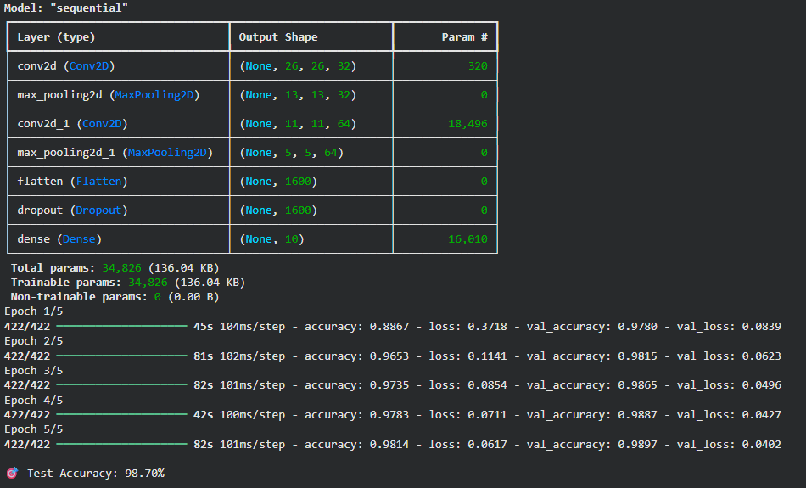
Output 2: Sample Test Predictions with Confidence Scores
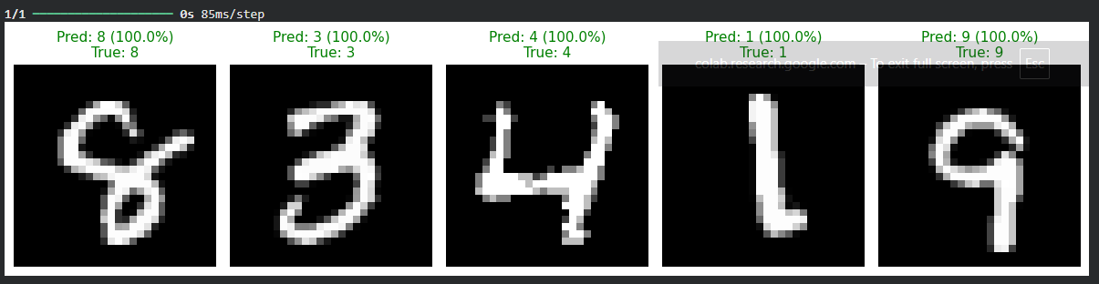
Output 3: MNIST 10-Class Confusion Matrix and Classification Report
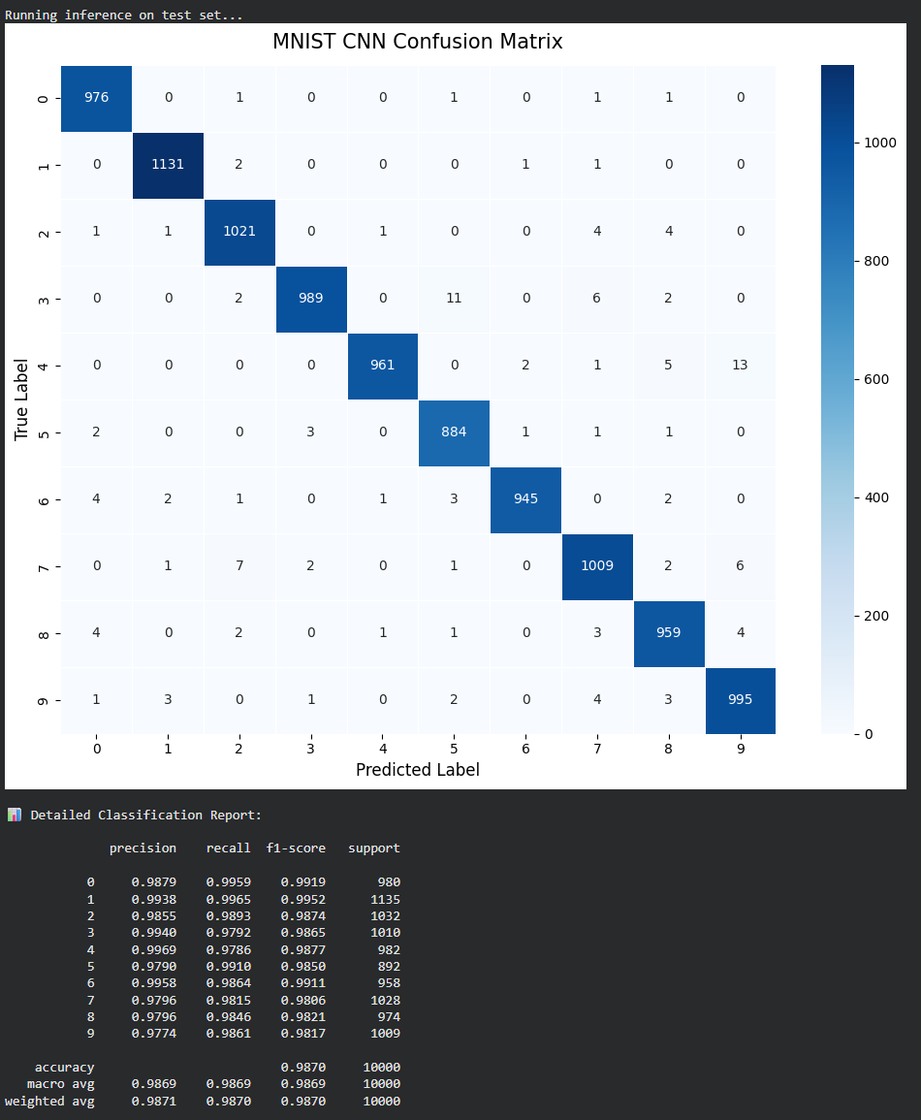
Output 4: Inference Latency and Testing Time Benchmark
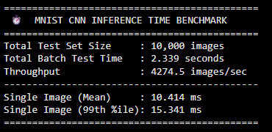
3. EXPERIMENTAL TABULAR RESULTS
Table 1: Per-Digit Classification Accuracy and Testing Time
 | Accuracy | Testing time
Digit | in % | Constant ( in ms )
0 | 99.59% (0.9959) | 10.414
1 | 99.65% (0.9965) | 10.414
2 | 98.93% (0.9893) | 10.414
3 | 97.92% (0.9792) | 10.414
4 | 97.86% (0.9786) | 10.414
5 | 99.10% (0.9910) | 10.414
6 | 98.64% (0.9864) | 10.414
7 | 98.15% (0.9815) | 10.414
8 | 98.46% (0.9846) | 10.414
9 | 98.61% (0.9861) | 10.414
ovr | 98.69% (0.9869)
Table 2: Epoch-wise Training Accuracy Progression
epoch | Training accuracy
1 | 88.67% (0.8867)
2 | 96.53% (0.9653)
3 | 97.35% (0.9735)
4 | 97.83% (0.9783)
5 | 98.14% (0.9814)
RESULT: The Convolutional Neural Network (CNN) for handwritten digit classification was trained and tested on the MNIST dataset. The model achieved an overall test accuracy of 98.70% (macro recall: 98.69%) with a mean single-image inference time of 10.414 ms.

